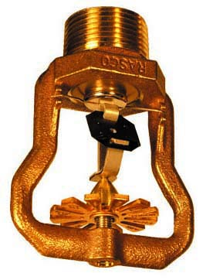

Engineering Specification
Model HL-22 ESFR

Sprinklers shall be Early Suppression Fast Response (ESFR) pendent suppression mode sprinklers [cULus Listed]* [FM Approved]* for commodity storage applications. Sprinkler frame and deflector to be of bronze construction with deflector located inside of the frame arms. Sprinkler shall have a maximum listed/approved ceiling-to-deflector distance of 18”. Fusible alloy solder link assembly shall utilize the strut and lever principle of operation with approved fast response beryllium-nickel thermal element with protective [black painted (165 ºF)] [gray painted (212 ºF)] coating. Water seal shall consist of a Teflon-coated Bellville spring washer and brass cap assembly containing no plastic parts. ESFR sprinklers shall have a nominal K-factor of 22.4 and 1” NPT threaded end connections. Sprinkler temperature rating shall be [Ordinary 165 ºF (74 ºC)] [Intermediate 212 ºF (100 ºC)]. ESFR pendent sprinklers shall be Reliable Model HL-22, SIN RA1011 (Bulletin 010).

* Note: cULus Listed for 165 ºF (74 ºC) and 212 ºF (100 ºC)
FM Approved for 212 ºF (100 ºC) only

